1. **Introduction and Association with the Literature**

The task, intended to be accomplished, is to transfer money from one of the user's checking accounts to another via the Denizbank Mobile Banking application. The sequential flow of operations within the application when all tabs are opened correctly can be seen in Figure 1.

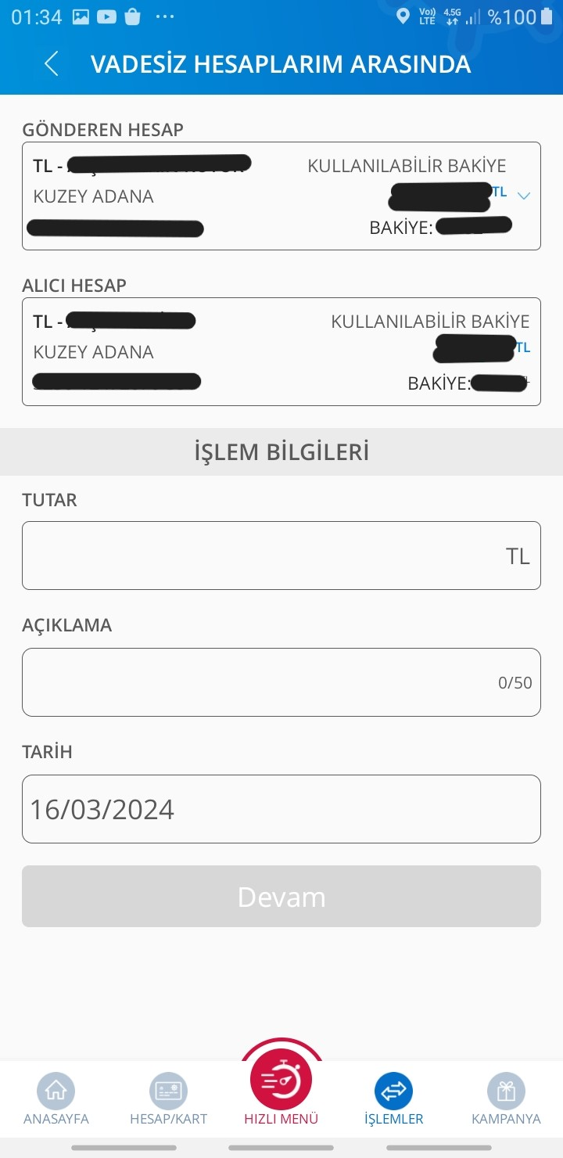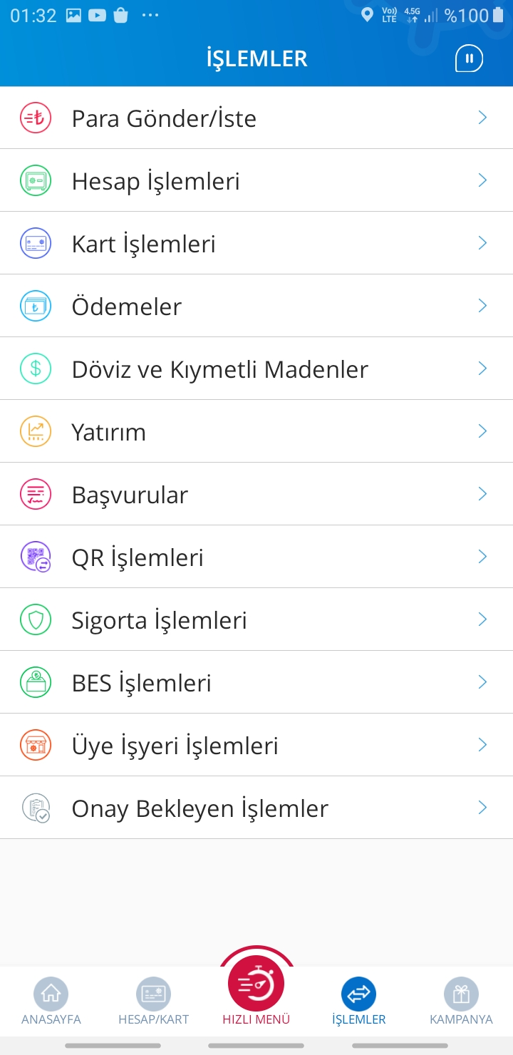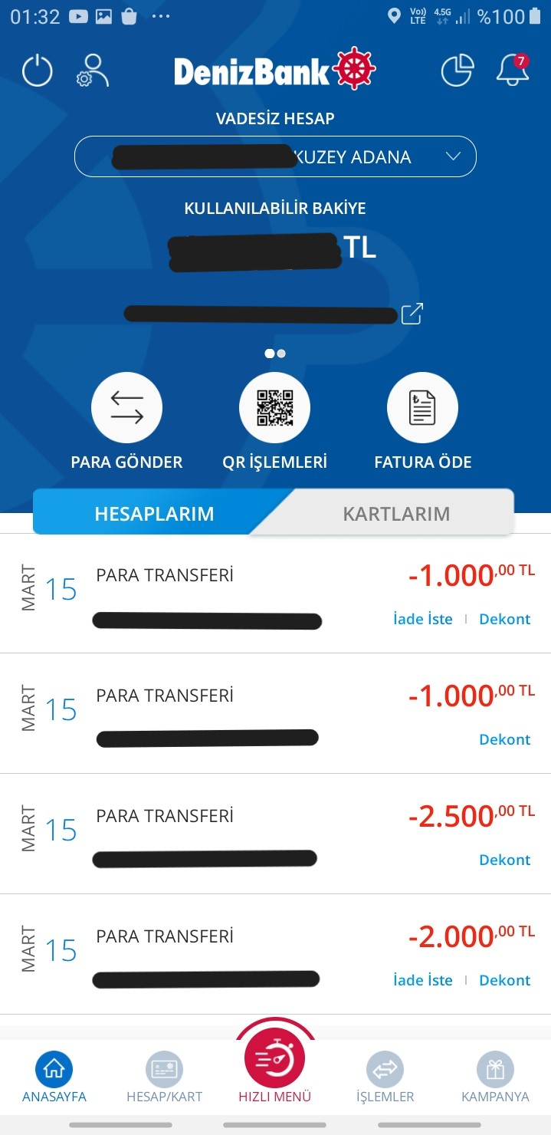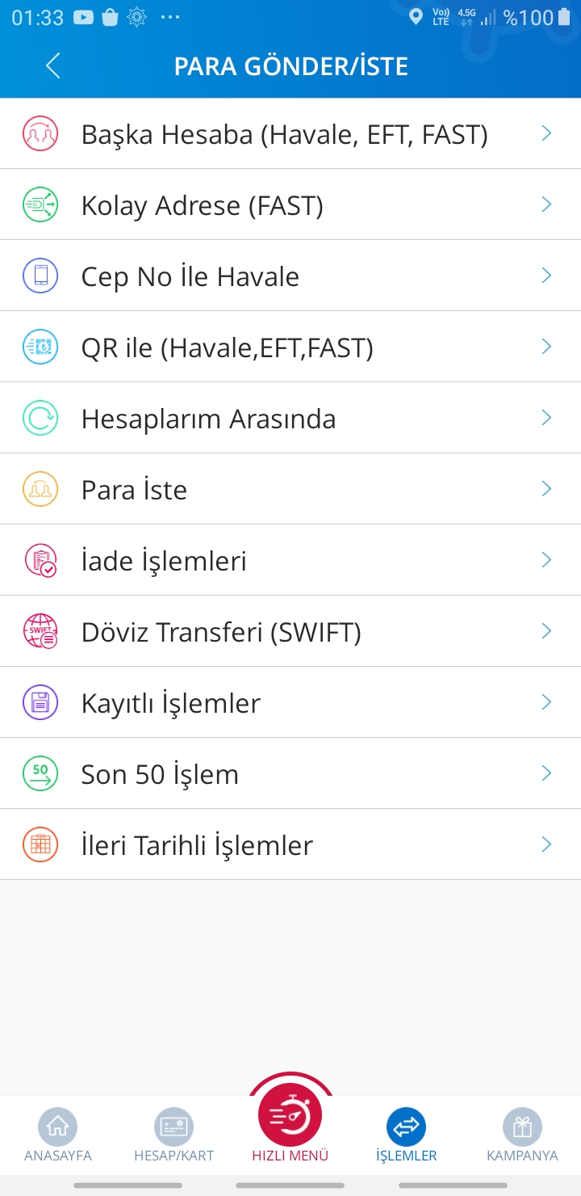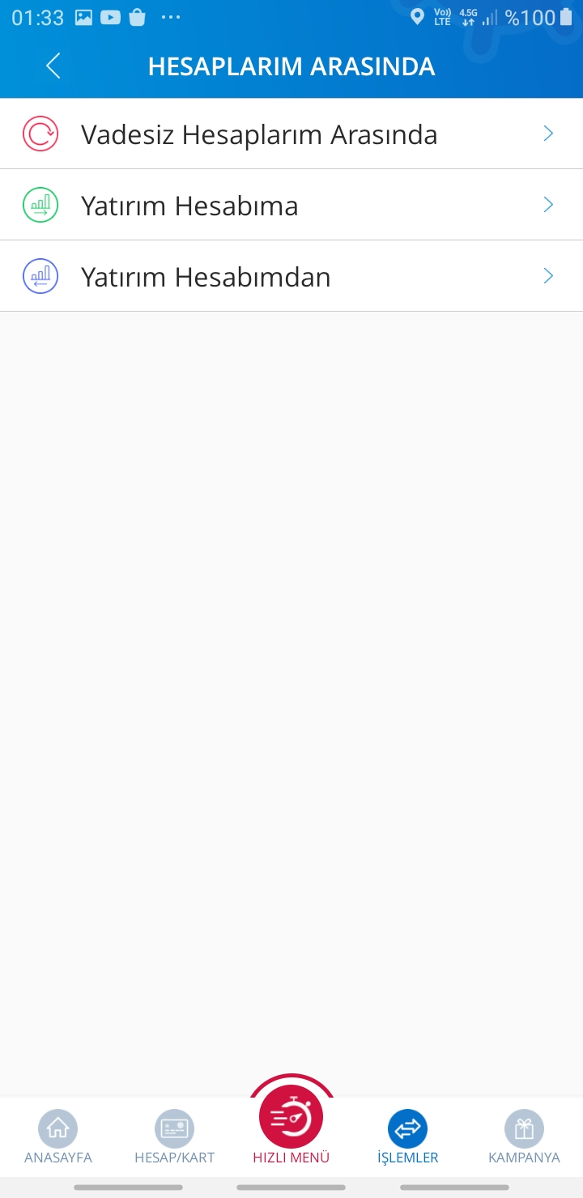

Figure 1

In order to successfully execute the transaction, it is imperative to sequentially navigate through the tabs labeled "İşlemler", "Para Gönder/İste", "Hesaplarım Arasında", and "Vadesiz Hesaplarım Arasında". On the final screen, the user is prompted to input the amount and provide an explanation. Upon entering the required "amount data", the "Devam" button is enabled. Additionally, it is pertinent to note an important aspect not depicted herein; after the "Devam" button is clicked, the application provides a confirmation screen, affirming the successful finalization of the operation.

Although this flow chart may appear straightforward, it contains some challenges and always results in my mother handing the phone to me after tens of minutes of effort. With the increasing use of electronic tools in the Pervasive Age, interfaces entered into interaction with all users, and "User Interface Design" began to be seen as a sub-discipline of HCI (Cagıltay, Cagiltay, & Gurcan, 2021). Devices that were once exclusive to a specific demographic have now evolved into ubiquitous tools integral to the daily lives of the vast majority. Therefore, it is pertinent to examine the challenges encountered in this specific mobile application through the context of Human-Computer Interaction (HCI) principles.

In the workflow depicted in Figure 1, two issues have been faced. The first problem pertains to misleading labels encountered on the third screen in Figure 1. In the "Para Gönder/ İste" tab, the user is intended to send money to his/her other account, and the first option she sees is "Başka Hesaba (Havale/ EFT, FAST)". Since this is the primo alternative encountered on the screen and the user fundamentally wants to send money "from her one account to another", she intuitively enters this tab directly without looking at the correct option which appears in the fifth place, named "Hesaplarım Arasında".

As stated by Shneiderman and Plaisant (2016), one of the critical points that UI designers should focus on is considering users who may not find the correct interface component due to incomprehensible icons or labels. Just as consistency must be taken into consideration when designing the application, the user's planning and decision-making process while performing the action must be reviewed consistently as well (Norman, 2013). The user decides that the logical step is to go through "İşlemler", "Para Gönder/İste", "Başka Hesaba (Havle/ EFT, FAST)" instead of the path specified by designers "İşlemler", "Para Gönder/İste", "Hesaplarım Arasında". After this stage, the user who chooses the wrong option does not realize that she is in the wrong tab as she does not receive any feedback from the application and thinks that she can send money by entering her own account information.

So, what steps does the user need to go through to find his account number? The user must first go to the first screen shown in Figure 1 by clicking on the "Anasayfa" button below. On this screen, one must select the account to which she wants to send money and press the send sign next to the account number. However, when this sign is clicked, the user cannot copy the account number directly. In the fastest scenario, she is supposed to send the account number to someone from a communication application such as WhatsApp and then copy it. After all these operations are completed and the information requested by the application is entered on the final screen, an error tab, which can be seen in Figure 2, appears. In other words, the user's completion of the 7. stage of Noman's 7 Stage Model, that is to compare her current state to her goal of transferring money from one of her accounts to another and realizing her action did not lead to the expected outcome, required the user to switch to another application, and go through many screens again to finds out that she made a mistake (Norman, 2013).

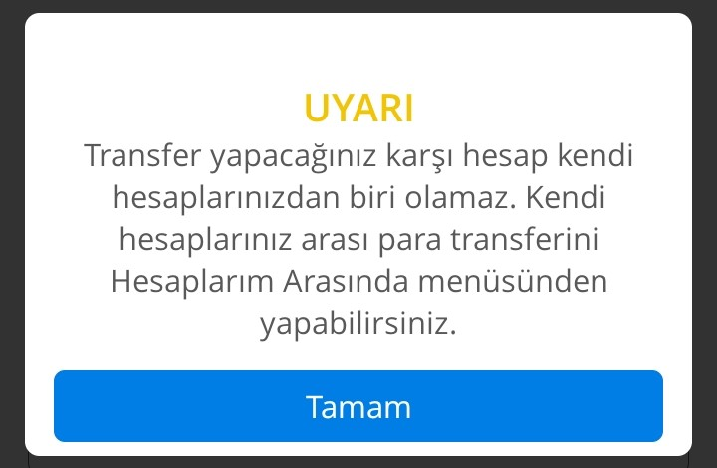

Figure 2

An additional complication arises within the application's interface, specifically on the "Hesaplarım Arasında" screen, as illustrated in Figure 1. Here, users are confronted with three options. While my familiarity with the distinctions between a checking account and an investment account ensures that I face no difficulties at this juncture, my mother's unfamiliarity with such terminology results in her inability to proceed with the operations on this screen, thereby transferring the issue to me. This scenario underscores Shneiderman's assertion in his 8 Golden Rules, highlighting the importance of considering factors such as user age and technological proficiency during the design phase. During the design process, the user's experiences should be taken into account (Dix, Finlay, & Gregory, 2004), and users with different backgrounds must be taken into consideration (Shneiderman & Plaisant, 2016).

**2. Recommendations, Proposed Solution (3 pts)**

The purpose that the user first envisioned in the bridge of evaluation stages is "to send money from one account to another". When a connection is established between evaluation and execution, it seems quite normal for the user to choose "Başka Hesaba" (To another account), which is the first tab that appears. The user establishes a correlation between the first option she sees and the cognitive action in her mind. Therefore, it seems more logical to put the "Hesaplarım Arasında" option in the first order. However, the user may still have difficulties to make the connection. For this reason, instead of the "Hesaplarım Arasında" tag, "Kendi Hesabıma" tag can be used, and instead of the "Başka Hesaba" label, "Başkasının Hesabına" label can be used.

Furthermore, while we did not personally encounter issues in the transaction process we focused on, navigating through the "Para Gönder/İste" option on the second screen in Figure 1 leads users to a subsequent screen where the "Para İste" option appears once more. The repetition of the same label across two consecutive screens could potentially create confusion, giving users the impression of redundancy or that they have made an error. Although this specific issue was not part of our initial discussion, it is worth considering the separation of the "Para Gönder/Al" tab into distinct "Para Gönder" and "Para İste" options to enhance clarity and user navigation.

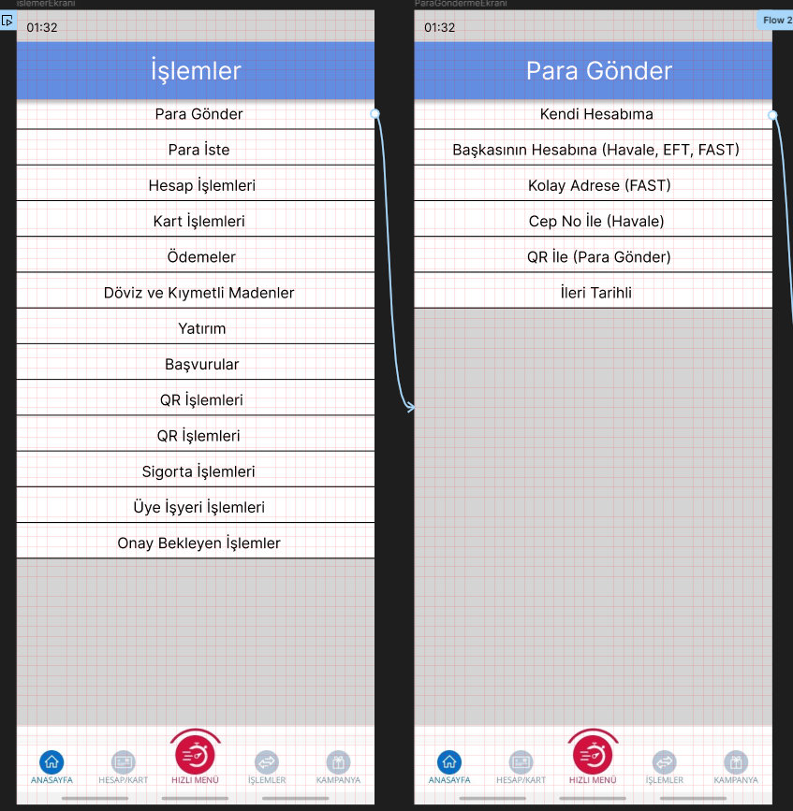

Figure 3

Changes made using Figma can be seen in Figure 3.

When dealing with the second problem, it is necessary to consider different types of users. Assuming that every user has knowledge of banking terms will lead to a wrong design process. As suggested by Shneiderman (2016), "It is required to recognize the needs of diverse users and seek universal usability". Due to the limited scope for conducting in-depth research on the matter, the solutions implemented by other banking institutions as alternative references are explored. In the Akbank Mobil Application, a component similar to the dropdown menu is used in order to display all the accounts belonging to the user. It can be seen in Figure 4.

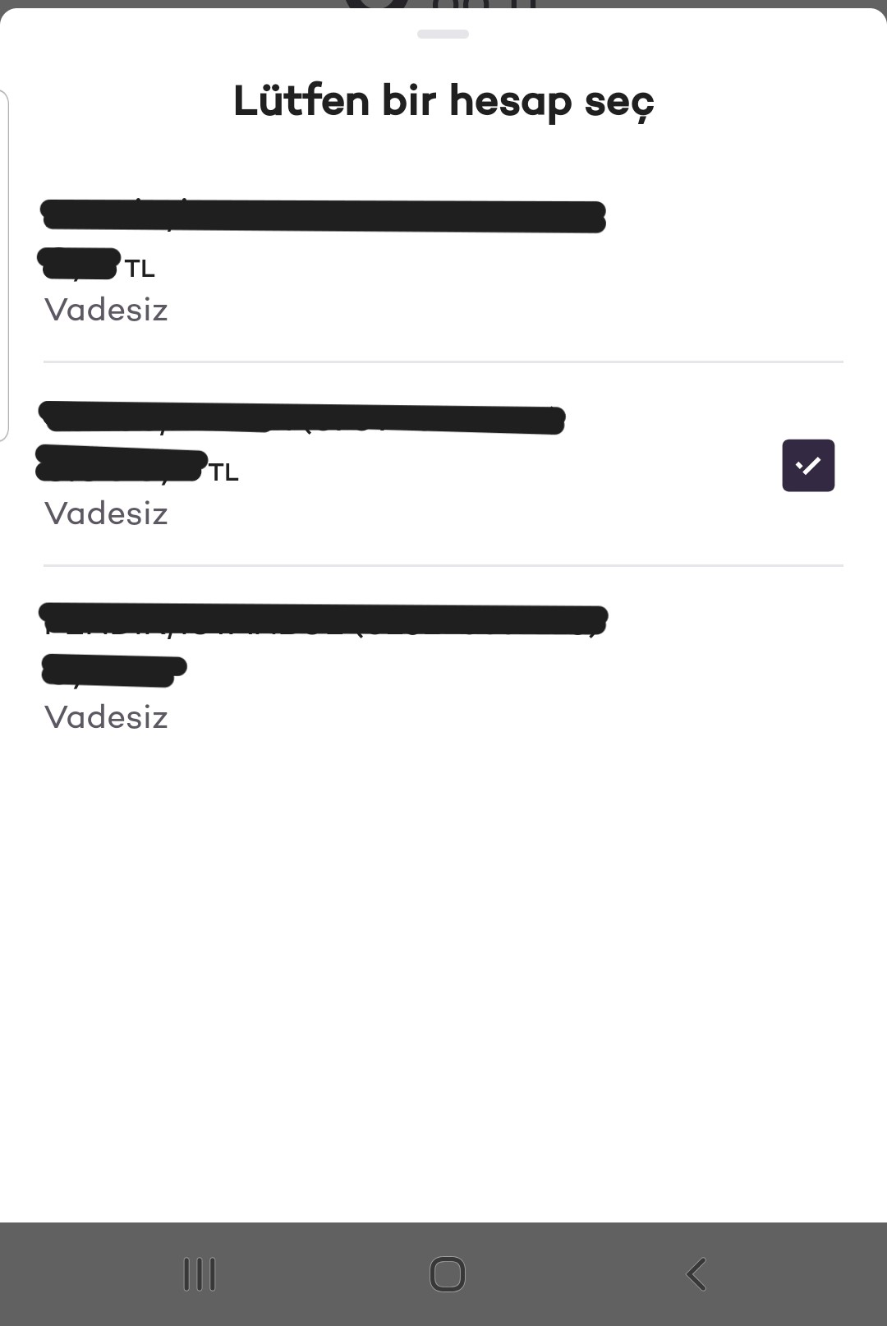

Figure 4

The comparison between Denizbank and Akbank's mobile applications indicates that Akbank adopts a user-centric approach by not assuming familiarity with financial terminologies among its users. Also, Akbank does not offer options such as "Yatırım Hesabıma" to all users, without considering if they have investment accounts or not. This method enhances accessibility and engagement by accommodating a diverse user knowledge base. The changes made in this regard are seen in Figure 5.

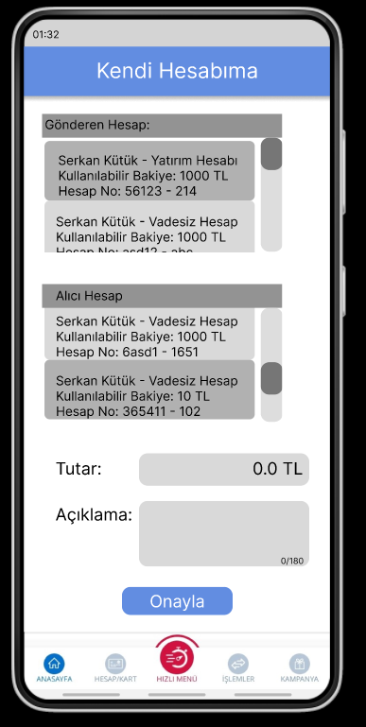

Figure 5

Figma link can be accessed from <https://www.figma.com/proto/V8nkNBkl6pNLdkYzuud9s3/Mobile-App-Denizbank?type=design&node-id=12-1077&t=c5CjF6HdvExHglyz-1&scaling=scale-down&page-id=0%3A1&starting-point-node-id=1%3A2&show-proto-sidebar=1&mode=design>

**3. References**

Cagıltay, K., Cagiltay, N. E., & Gurcan, F. (2021). *Mapping Human–Computer Interaction Research Themes and Trends from Its Existence to Today: A Topic Modeling-Based Review of past 60 Years.* International Journal of Human–Computer Interaction.

Dix, A., Finlay, J., & Gregory, A. (2004). Introduction. In A. Dix, J. Finlay, & G. Abowd, *Human Computer Interaction* (pp. 1-8).

Jacko, J. A. (2012). A Moving Target: The Evolution of Human–Computer Interaction. In J. Grudin, *The Human–Computer Interaction Handbook : Fundamentals, Evolving Technologies, and Emerging Applications (3rd edition).*

Norman, D. (2013). The psychology of everyday actions. In *The design of everyday things* (pp. 37-122). Basic Books.

Shneiderman, B., & Plaisant, C. (2016). Guidelines, Principles and Theories. In *Designing the User Interface: Strategies for Effective Human-Computer Interaction, 6th Edition* (pp. 81-120).